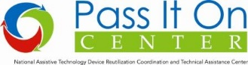

Shipping AT or DME for Disaster Response
The most important factors in planning to ship AT or DME for disaster response are:
- the safety of the intended users,
- safe transport for the equipment, and
- consideration for distribution factors at the destination.

Safety for Users

The mantra for AT reutilization is safe, effective, and appropriate. Devices need to be operational, mechanically or digitally sound, and sanitized.

Evaluate for condition. All devices and equipment should be lightly used and fully functional and operational. For the most commonly used item, manual wheelchairs, the recommendation is that they not be more than three years old. Devices should be checked for functionality. Simple adjustments or repairs should be performed before shipping.

Devices should not have stains or tears to vinyl or leather parts, or any surface defect that could tear the skin or injure the user in any way.

Sanitize Items prior to shipment. Devices should be cleaned appropriately for reuse to avoid any possibility of exposing a new user to health risks. Links to guidance for appropriately sanitizing devices are available in the wiki at http://pioc.gatech.edu/wiki/Hurricane_Harvey_2017 and in the Knowledge Base on the Pass It On Center website.

The conditions may not be appropriate to do this at the destination, the resources (even water) may not be available, and the staff there will be working under adverse conditions already. It is best to ship devices that are ready to use, and avoid mixing clean and dirty inventory. And, the device should be ready to be matched to an individual on arrival.

Safe Transport for Equipment: How to Ship

The good folks at Friends of Disabled Adults and Children (FODAC), a reuse partner of Tools for Life, Georgia’s Assistive Technology Act Program, have a simple checklist for preparations. Yours may be slightly different.
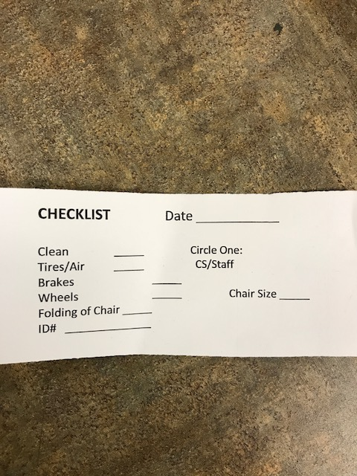 FODAC checklist to prepare wheelchair for shipping

Tag the device. After sanitizing the devices, tag each with information to facilitate use at the destination. This should include device name, model, type, size information or use specifications. For example: Manual wheelchair, adult, 250 lbs. (the weight limit),18x16 (the seat size).

Add a reuse sticker. Please place an adhesive reuse sticker on the device. A model for both 2x4-inch and 1x2 5/8-inch labels can be found on the Pass It On Center wiki at the link above. You may use your own logo, but please keep the guidance about loan status and how to return to a reuse center.

Package for shipping. If you have small devices or supplies that are not unusually heavy, choose a shipping box that is of appropriate size and construction. Wrap devices individually and add protective padding, Styrofoam peanuts, or air cushion packing to avoid damage.

Larger devices, especially wheelchairs, should have the accessories, such as foot rests or leg rests, attached so that it does not require a treasure hunt on the other end to find the accessory that fits. Small accessories or user manuals should be placed in a plastic zip bag and taped to the device.

If you are shipping large devices, especially wheelchairs, you should consider palletizing the shipment. This may be difficult if you do not have access to a loading dock and a forklift. Check with the shipper you plan to use before purchasing supplies. Determine what you can acquire from them and if they offer packaging, palletizing, or loading services.

The preferred packaging for manual wheelchairs and other large, heavy items is a large box or bulk bin commonly called a “Gaylord container” or a “Gaylord box”. They are designed to fit a standard pallet, and may have dimensions such as 42x51x38” (the latter being the height). They may be made of corrugated cardboard or heavy duty plastic. New Gaylord boxes appear on the Internet for $68 each, but the good news is that these are made to be reused and can be purchased from recyclers for $18-20. That does not include a pallet. Do a search for recycled Gaylord boxes available in your area.

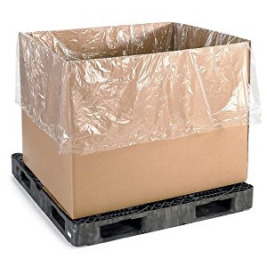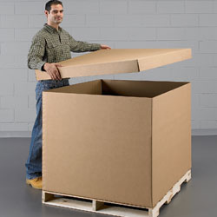
A Gaylord pallet container for recycling. Pallet not included. They have drop-in bottoms and full tops to enclose the box.

FODAC suggests that a Gaylord box will hold approximately seven manual wheelchairs.

Prepare a list of the contents. Please prepare a list of the box contents to email to the receiving organization. Place a copy in the box.

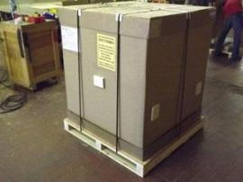
Gaylord container packed and strapped to a pallet.

Once the box has been filled, the Gaylord container, with its top, it should be strapped to the pallet.

Packing smaller devices. Smaller devices may be placed in individual boxes with appropriate packaging, and then combined on a single pallet. Smaller boxes may also be shipped individually if the number does not warrant palletizing.

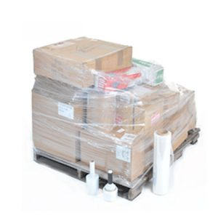
A pallet that combines numerous small devices packaged separately.

Ask before you pack!

- These boxes and pallets cost money. Do not hesitate to locate a provider in your area and ask if they will donate packaging for disaster response.

- If you have questions about resources or procedures, please contact the shipper before you pack.

