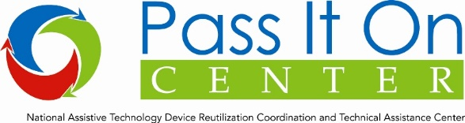

This equipment is loaned through The Pass It On Center Network Disaster Response Effort and should not interfere with an individual's ability to receive new equipment if they are eligible.

When you have finished using this equipment, please return it to the organization where you received it or to your local reuse program.

Please go to www.passitoncenter.org to find your local reuse program.

